CALIX E3-16F & E5-16F

G.Fast SMx Programming

(Remote Tech Assist)

Table of Contents

1.0 Overview 3
2.0 Effective Date 3
3.0 Related Links 3
4.0 Overview 4
5.0 Login 4
6.0 View Service 6
6.1 Using the Search window to View Subscriber 6
6.2 Searching for a Subscriber using the Subscriber Tab 9
6.3 Manual Port Search 12
7.0 Create Subscriber 15
8.0 Edit Subscriber 22
9.0 Edit Data Service 25
10.0 Pause Service 26
11.0 Resume Service 28
12.0 Deleting Service 29
12.1 Deleting the Subscriber 29
12.2 Deleting the GFAST Interface 30
13.0 Firmware 31
14.0 Troubleshooting 31
14.1 How to Verify the Subscriber’s IP Address 31
14.2 How to View Authentication on all of the Ports on the DPU 32
14.3 How to Resynchronize the CLLI 33
15.0 Videos 37
16.0 Document Management 37

Overview

Target Audience | Programming
Impact/Benefit | This document provides steps for programming G.fast for CALIX E3-16F and E5-16F device types, using the Axos SMx EMS (Element Management System).  *SMx EMS will replace the previous “Activate” network manager.
Reason for Change | Added context in the Overview section.  Added document links in the Related Links section.  Added the Firmware section.

Effective Date

Effective Date | Expiration Date
04/25/22 | Until Further Notice

Related Links

Link and Name
NetworkCo SMx (access thru AVD): https://ntco-smx.corp.intranet:3443/smx
Calix E3-2 GPON SMx Programming (QF Tech Assist).docx
Video: G.Fast – Calix SMx Create Programming.webm
Video: G.Fast – Calix SMx Verify Programming.webm
Quantum Fiber - CASA (QF Structure Load and QF Tech Assist).docx
UNIQual Polygon Info (QF Structure Load).docx
Visit the library to view all documents: https://centurylink.sharepoint.com/sites/NAOLibrary

Overview
G.Fast (G-Series Fast Access to Subscriber) technology allows the company to improve broadband service for existing and underserved MDU/MTUs, where placing new fiber or Cat5e/6 to the unit is cost prohibitive. G.Fast programming and capabilities will vary slightly based on the device type:
CALIX E7 Casa G.Fast:
- Supports 940M
- Casa ONT type, all other programming BAU in CALIX E7.
- See the Casa document: Quantum Fiber - CASA (QF Structure Load and QF Tech Assist)

CALIX E3-16F/E5-16F G.Fast:
- Programmed in CALIX SMx
- Supports up to 500M
- Cannot have speeds above 500M/100M
- When Optius displays 500M/500M, the customer gets provisioned as 500M/100M
- If customer is sold a speed higher than 500M, Remote Tech Assist will need to create a case to Engineering to have the Polygon corrected, and also a Callback case to have the Speed on the Account corrected.
  - Tip: See the Polygon Corrections section of UNIQual Polygon Info (Structure Load and Remote Tech Assist) document.

ADTRAN:
- Supports 940M
- Programmed in MOSAIC.

Note: CALIX E3 & E5-16F G.Fast is limited to 500M and will be discontinued; ADTRAN is the preferred device for G.Fast technology, but we will continue to support what is currently in place for E3 & E5-16F.

Login
There are 2 instances of CALIX SMx – One for Lumen, and one for Brightspeed, which is also where the Wisconsin T096 properties are.

Lumen SMx: https://155.70.106.84:3443/smx/

Brightspeed SMx: https://155.70.71.71:3443/smx/
Note: WI T096 is found here.

Username / Password = CUID (*Chrome is the preferred browser!)

Step | Action
Enter Username / Password and Select Login.

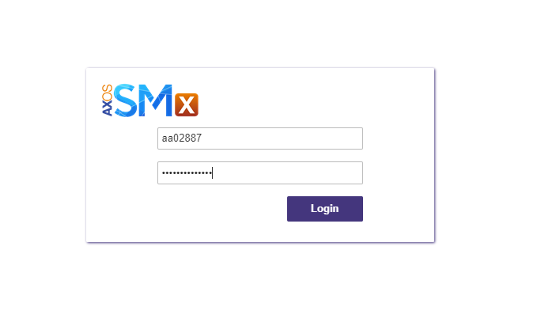

*If recieving an alert that the website is not secure, click “more information” and proceed.
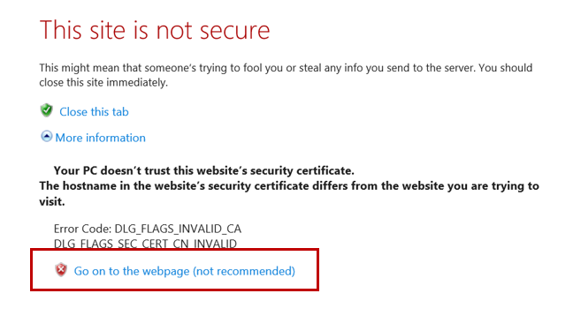

After login the agent should see the landing page displayed below.

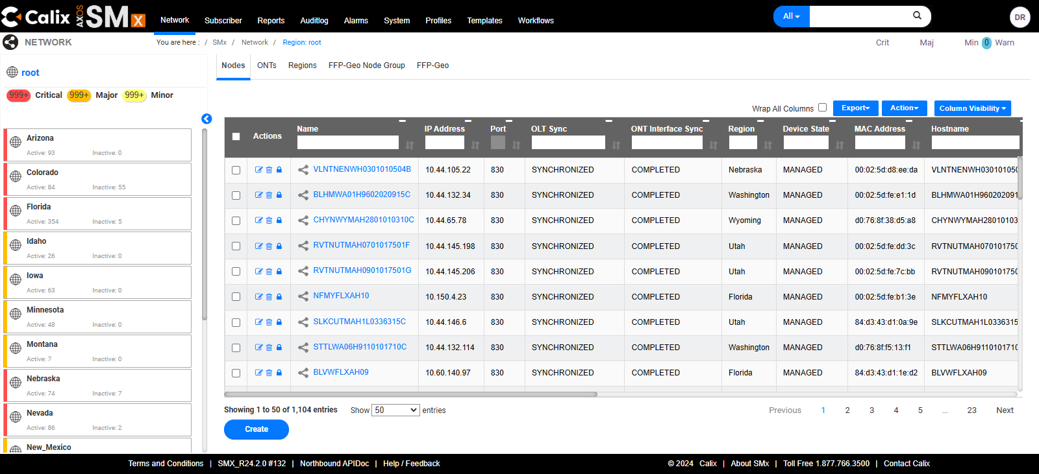
Select one’s username initials in the top right-hand corner will display a small menu including:
- Change Password
- Settings
- Log out.
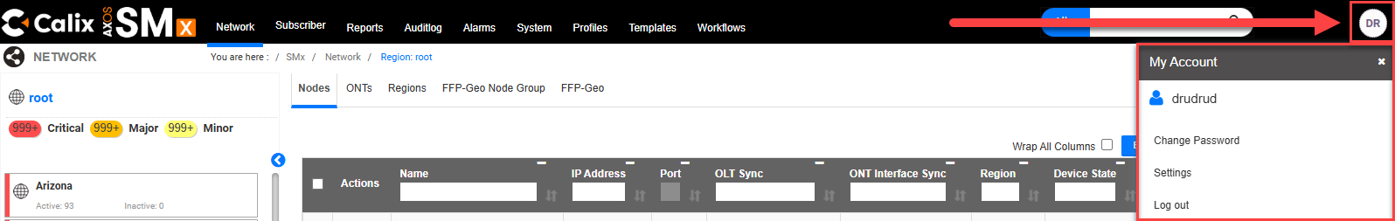

View Service
Agent can view service by searching for the subscriber TN / DTN (Subscriber Search), or by navigating to the Device and viewing the port (Manual Port Search).

A normal view for G.FAST would display both INTERFACE and SUBSCRIBERS.

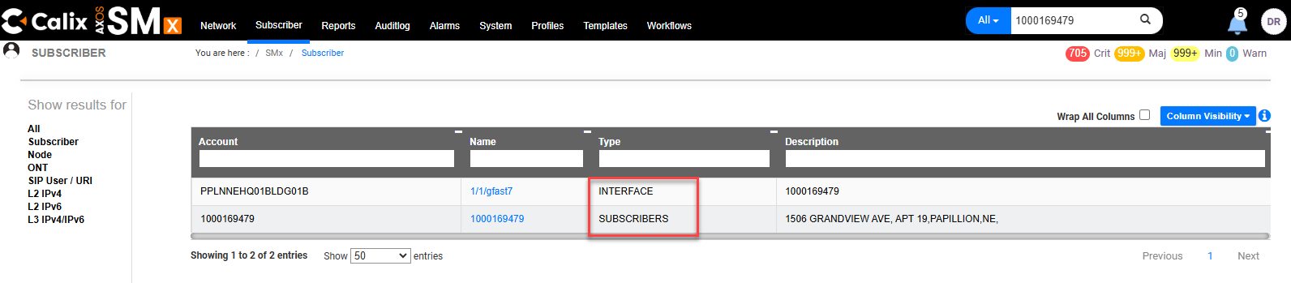

Using the Search window to View Subscriber

Step | Action
Change Filter from All to Subscriber.

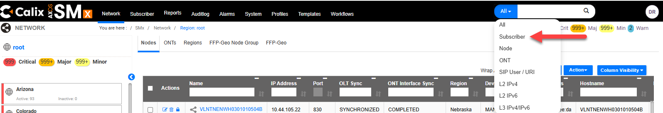
 | Enter the subscriber’s TN/DTN in the Search bar and press enter or select the looking glass.
Select the TN/DTN in blue text.
Tip: If no subscriber returned, see Create Subscriber for steps to create.

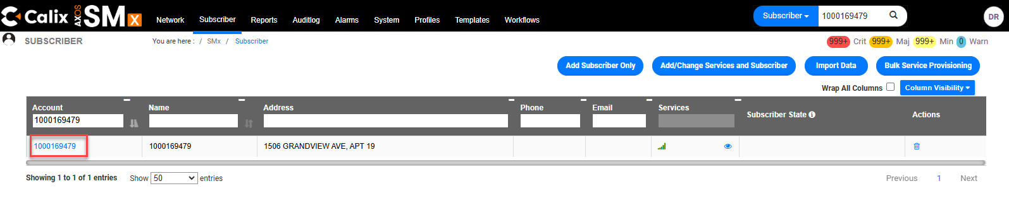
The top section of Provisioned Services will display:
- OLT Name & Port
- ONT
- Registration ID

The Data section will display:
- Service Template (Speed)
- VLAN (VPI)
- CTAG (CVLAN / VCI)
The example below shows the customer is programmed for 500M, with SVLAN 2857/CTAG 2007.

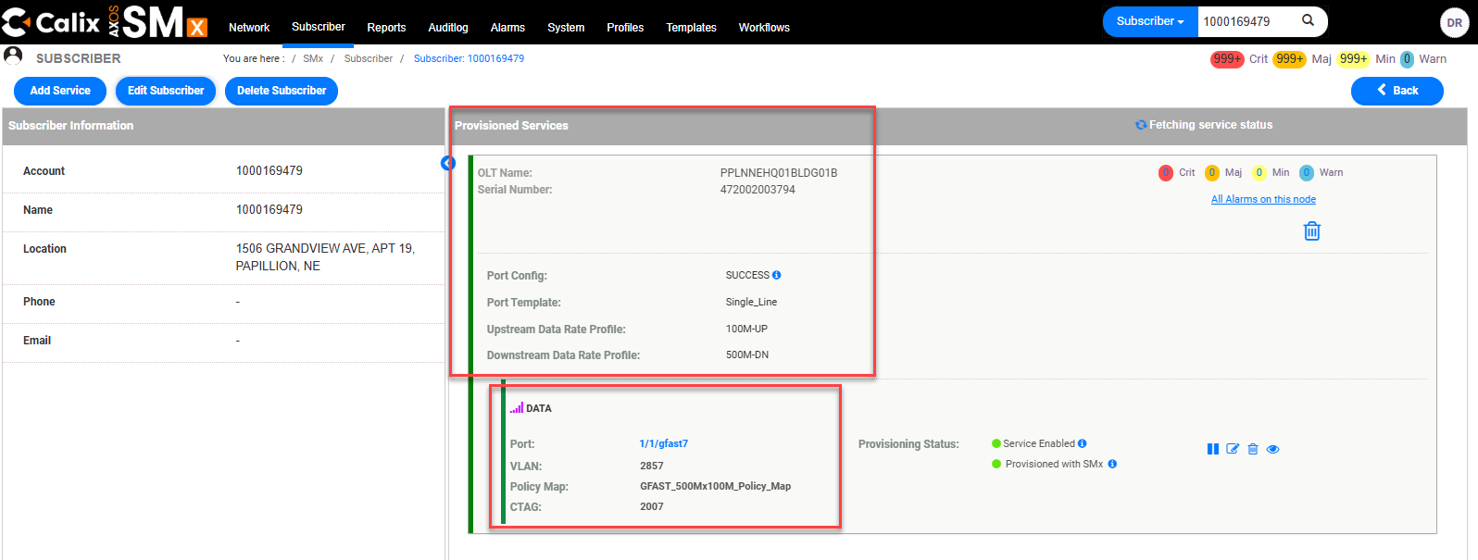

Note: If a second DATA port with a VLAN of 85 appears, DO NOT delete it. This is normal. If only a DATA port with a VLAN of 85 appears, the subscriber programming is incomplete, and needs to be created. See the Create Subscriber section of this document.
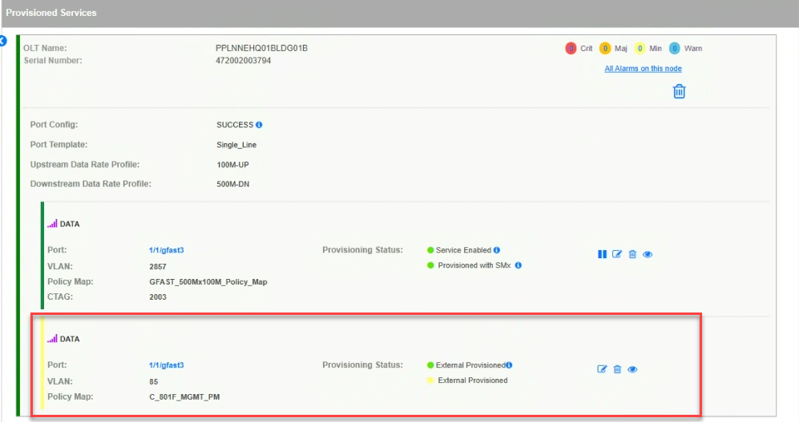

Searching for a Subscriber using the Subscriber Tab

Step | Action
Select Subscriber.

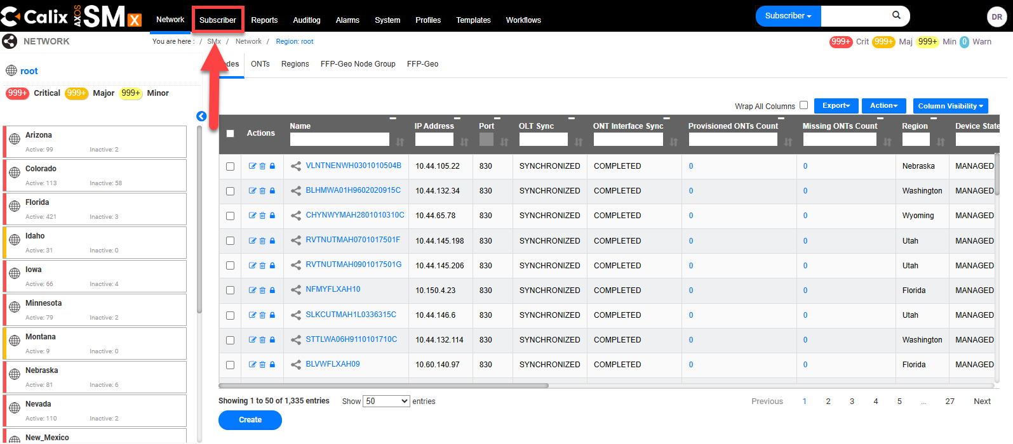
Populate the DTN in the Account field.

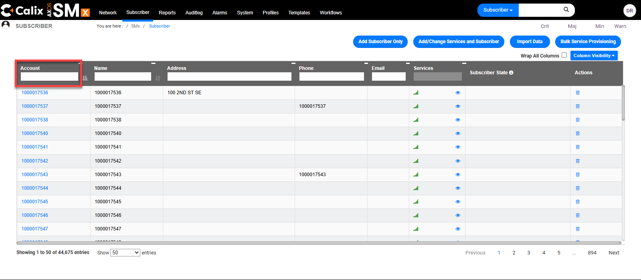
Select the hyperlink for the corresponding result.
Tip: If no subscriber returned, see Create Subscriber for steps to create.

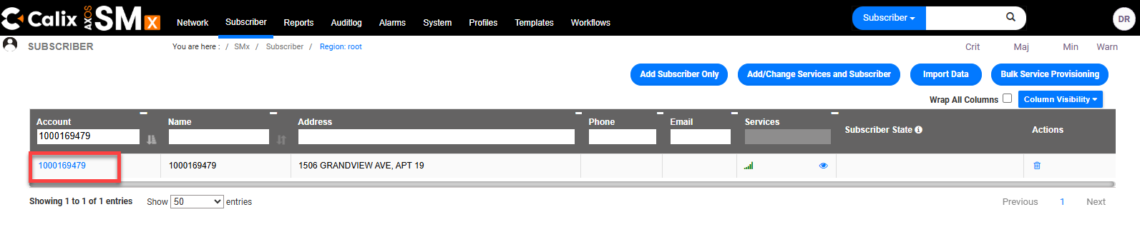
The top section of Provisioned Services will display:
- OLT Name & Port
- ONT
- Registration ID

The Data section will display:
- Service Template (Speed)
- VLAN (VPI)
- CTAG (CVLAN / VCI)
The example below shows the customer is programmed for 500M, with SVLAN 2857/CTAG 2007.

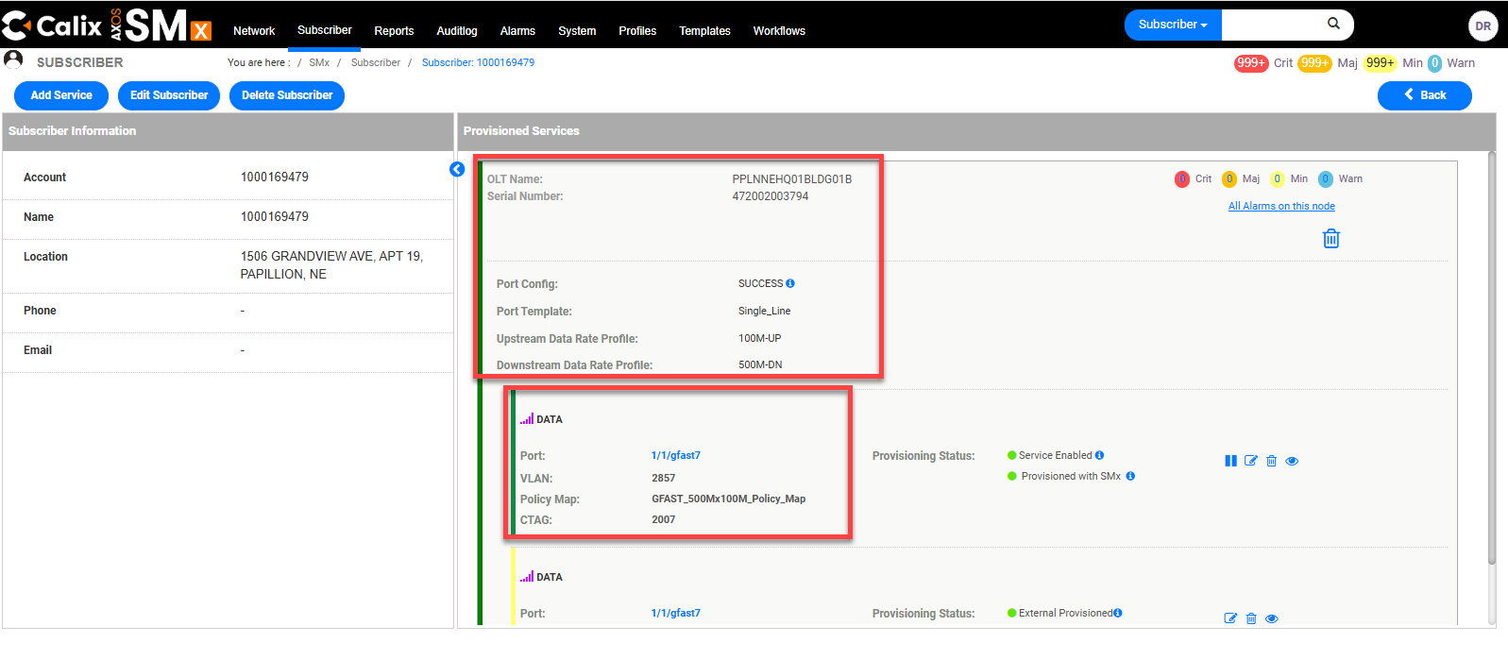

Note: If a second DATA port with a VLAN of 85 appears, DO NOT delete it. This is normal. If only a DATA port with a VLAN of 85 appears, the subscriber programming is incomplete, and needs to be created. See the Create Subscriber section of this document.

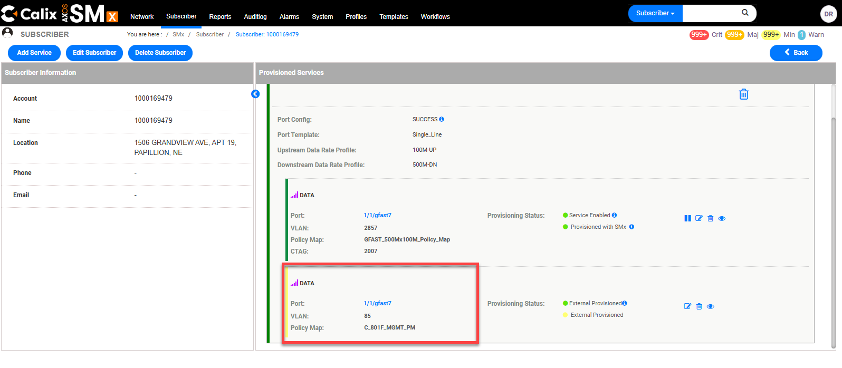

Manual Port Search
Following these steps can assist in verifying the programming on all the ports of the DPU providing an at large view of the DPU. This process will identify which subscribers are provisioned on which ports on the DPU as well as which ports are available on the DPU.

Tip: See the related video G.Fast – Calix SMx Verify Programming
The link for which can be found in the Related Documents section of this document.

Step | Action
From the Network tab (top menu), locate the Name field.
Note: Network should be defaulted to Nodes.

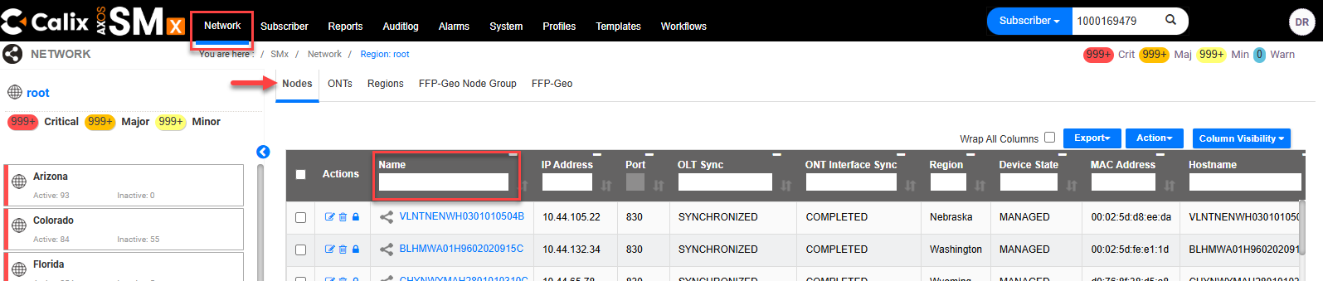
Input the device name in the Name search box.
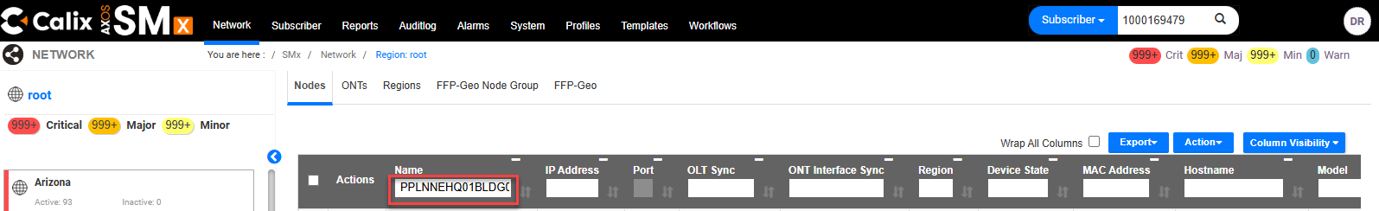
Select the Device name that returns in blue text (Example PPLNNEHQ01BLDG01B).
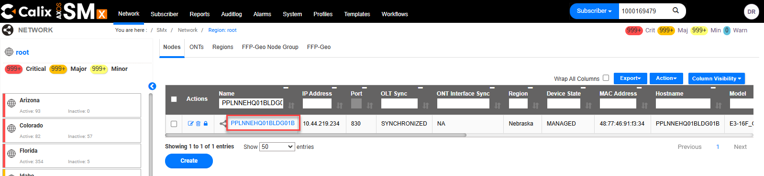
The Device will load with G.Fast ports 1 - 16 displayed on the left side.
Scroll down if needed to locate the port.
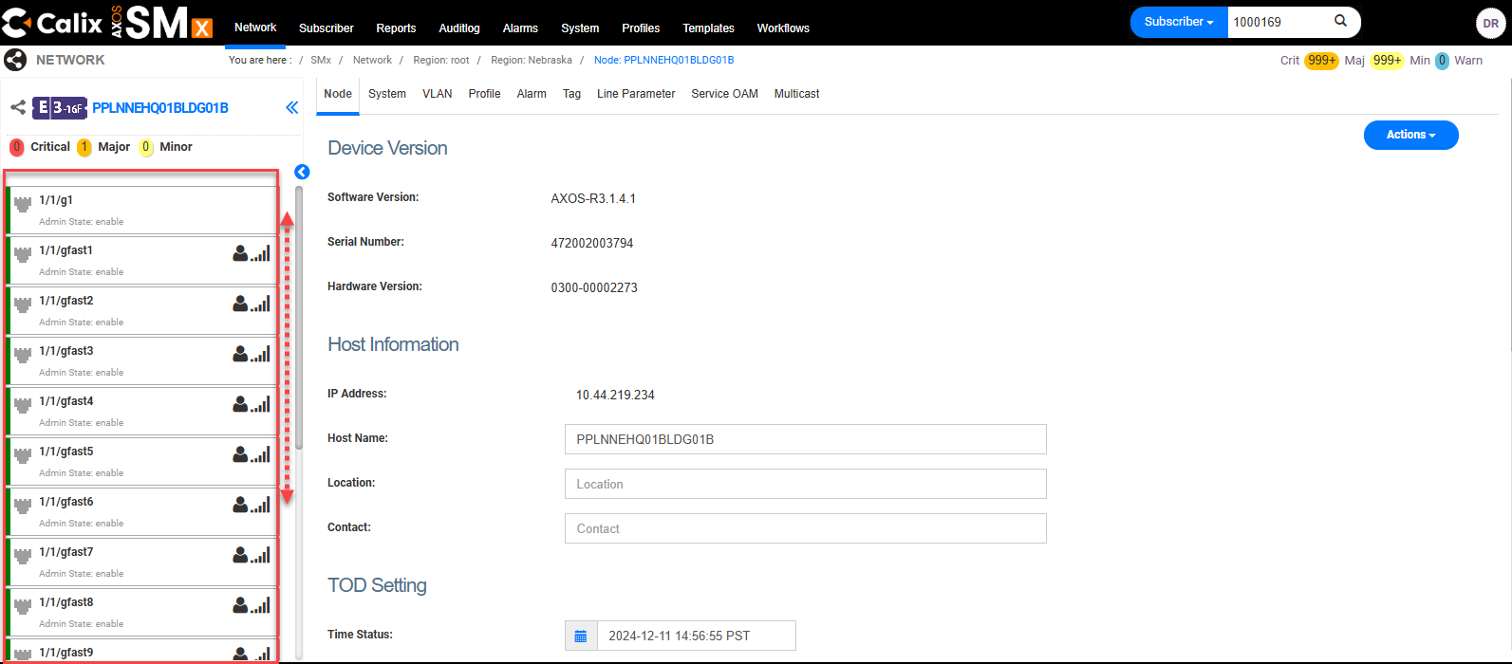
Scroll down to locate the port (Ex. Port 7). A provisioned port will show a Subscriber Icon and Services Icon .

Hover the mouse over the Subscriber Icon to display the customer’s TN / DTN:
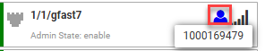

Hover the mouse over the Services Icon to display the customer’s VPI:
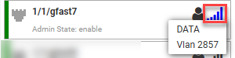
To review port programming, select the Subscriber Icon .

Tip: If there are no Subscriber or Service Icons, see Create Subscriber..

The example below shows data service programmed to Device
PPLNNEHQ01BLDG01B (OLT Name), Port 7 (port gfast7) with VPI/SVLAN 2857 (VLAN) and VCI/CVLAN 2007 (CTAG). Policy Map shows the speed profile 500Mx100M.

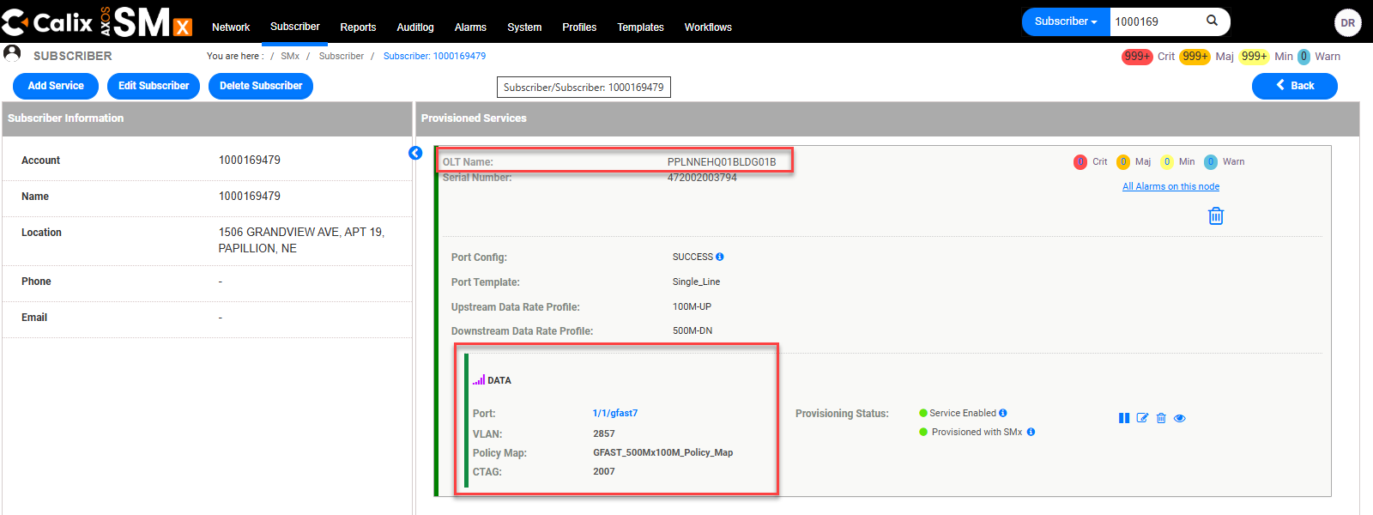

Create Subscriber
Tip: See the related video G.Fast – Calix SMx Verify Programming
The link for which can be found in the Related Documents section of this document.

Step | Action
 | Select Subscriber (top menu).
 | Select Add Subscriber Only.
Enter Customer’s TN / DTN in the Account and Name fields.
Enter the Address, City, and State.
Note: The Zip, Country, Phone, and Email fields are not required.
Select Submit.

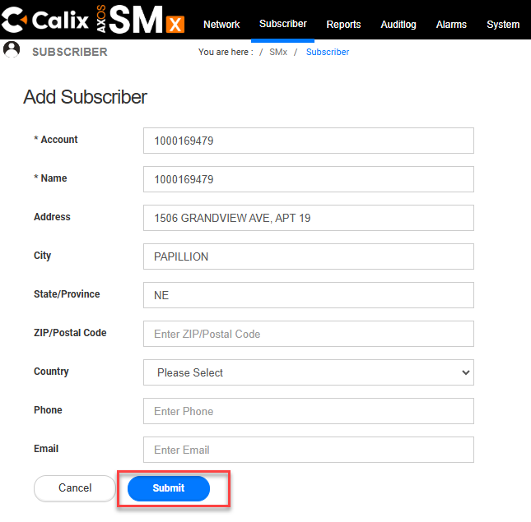
 | The screen should display a green alert message: “Subscriber has been created successfully”.
Input the Customer’s TN / DTN in the Account search box.
Wait for the results to populate.
Select the corresponding TN/DTN.

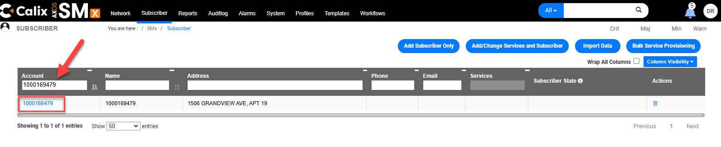
Select Add Service.

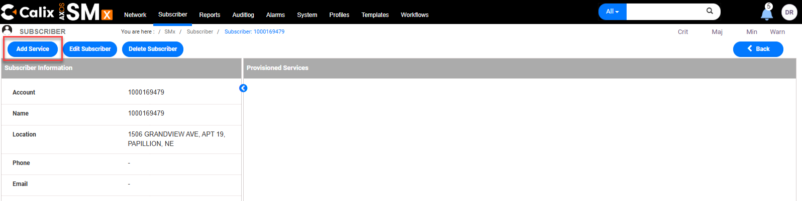
Populate the Device name in the search bar to locate the device.
Tip: Be sure there are no spaces before or after the device name.

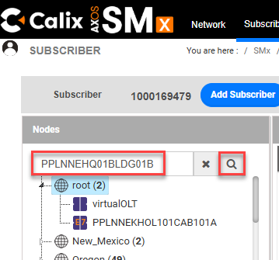
Locate the device, it should be in red text.
Tip: may need to use the scroll bar.

Note: The device can also be searched manually by selecting the State and select Device from the navigation tree (Example Device PPLNNEHQ01BLDG01B) and scrolling down the list when needed to view the device name.

Select the device.

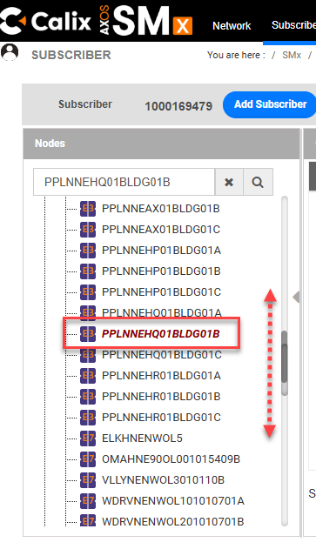
The ports are in order numerically following the 1, 10, 11, etc, then 2, 20, 21, etc logic.
May need to change the Rows per Page or select other pages to view all results.

Locate the Port.
Select the box next to the Port.
Select Next.

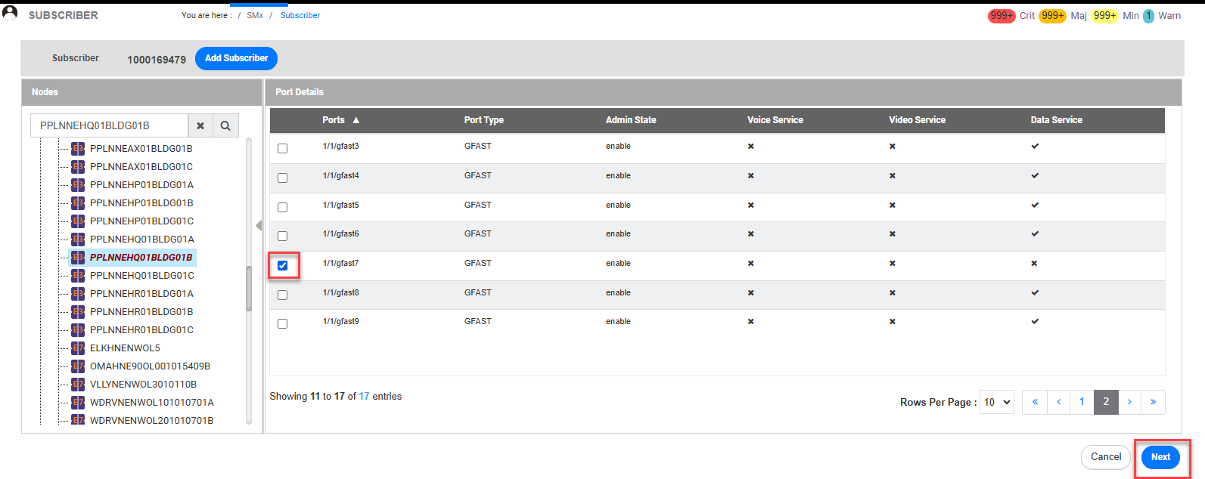
Using the Port Template drop-down, select Single_Line.
Note: New fields will display and Admin State, Downstream, and Upstream will auto-populate.

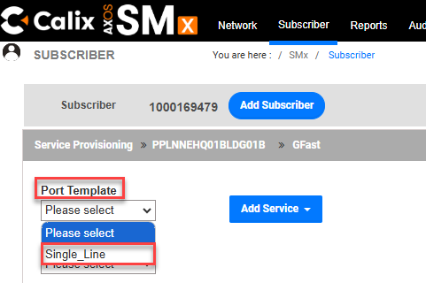
In the Service Template drop-down menu, select the subscribers purchased speed.
For example: If the subscriber’s purchased speed is 500M, select GFAST_500Mx100M.

Note: The Downstream Train Rate and Upstream Train Rate fields are auto populated and not editable.

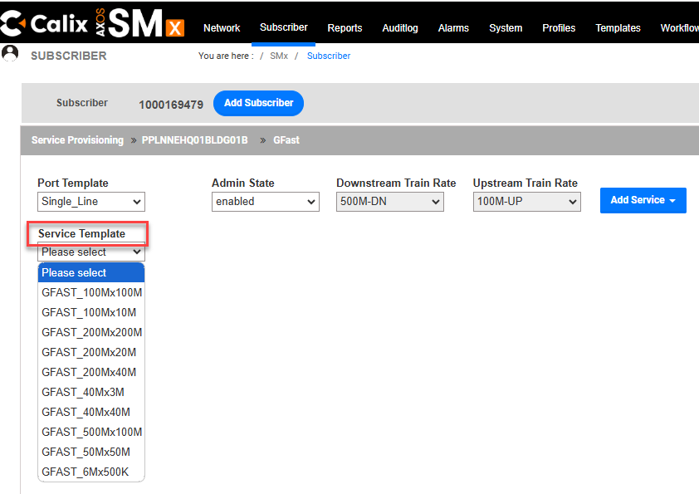
Fields will open and auto-populate to the right. Enter the assigned VPI (VLAN) and VCI (C-TAG).
Note: The Service Description field will remain un-populated.

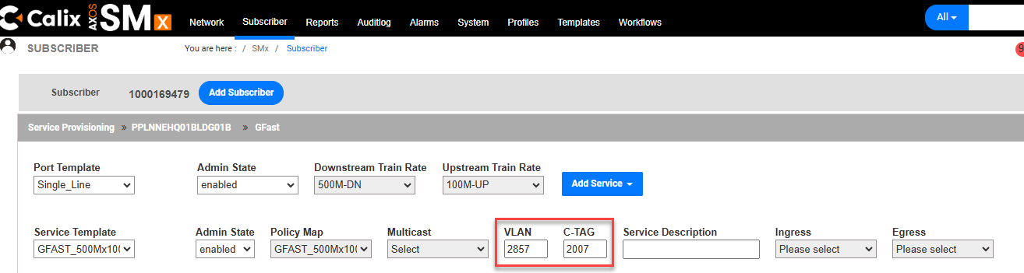
Scroll down to the bottom of the form and select Commit.

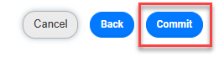
A The service provisiong has been started to device for subscriber (DTN/TN) message will display if the services were successfully created.

The created data service will display.
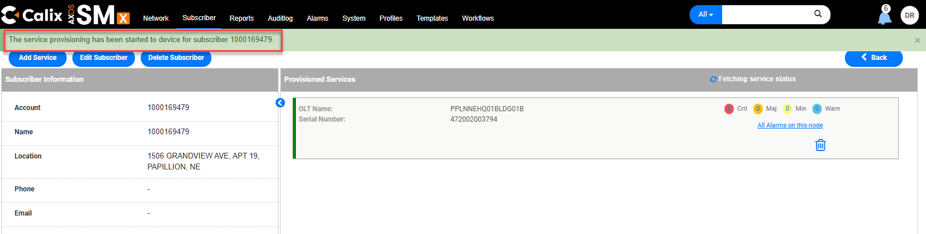
The screen will take a moment to auto-update and then the created data service will display.

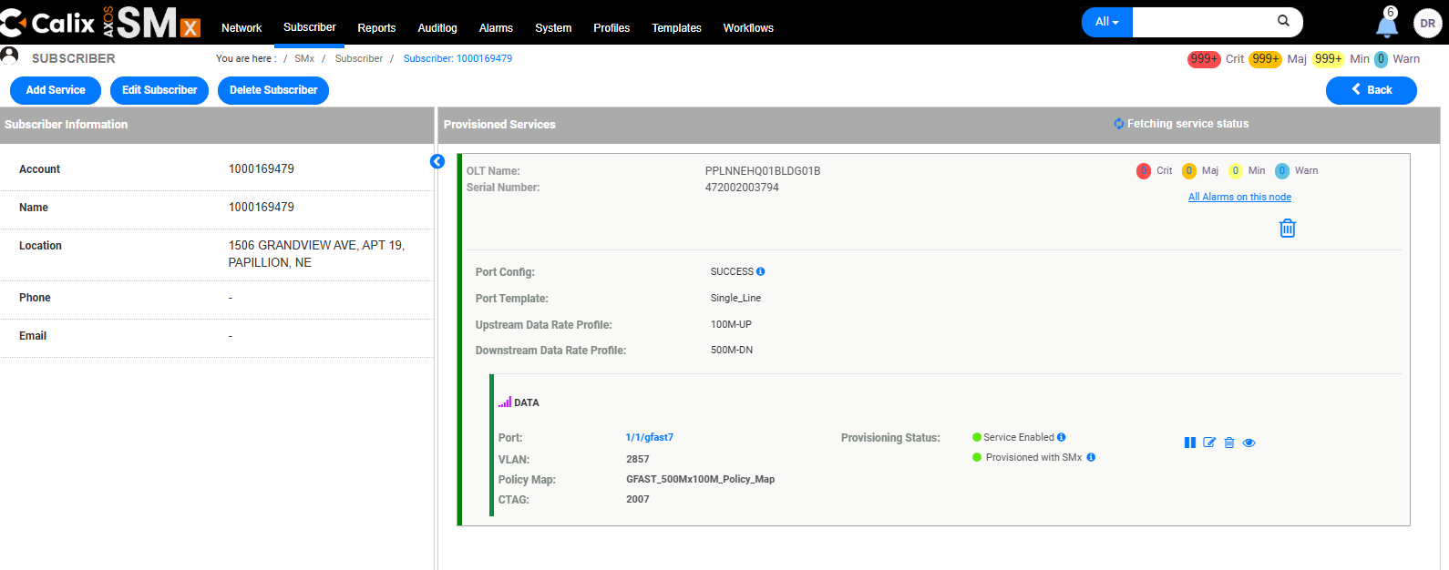

Edit Subscriber
This is used to change the Account, Name, or Address. In order to change the VLAN’s, see Edit Data Service.

Step | Action
View Customer’s TN / DTN (See steps for View Service if needed). Select Edit Subscriber.
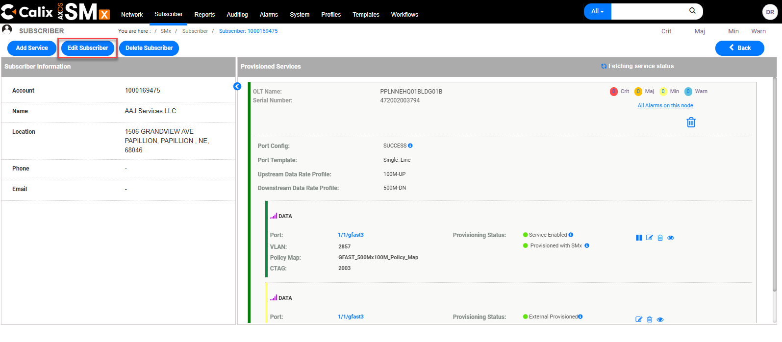
Edit Subscriber’s Name (DTN/TN), Account, or Address fields.
Tip: Zip Code, Country, Phone, and Email fields are not required.
Select Submit.

Note: The Account and Name field should be the subscribers DTN/TN.

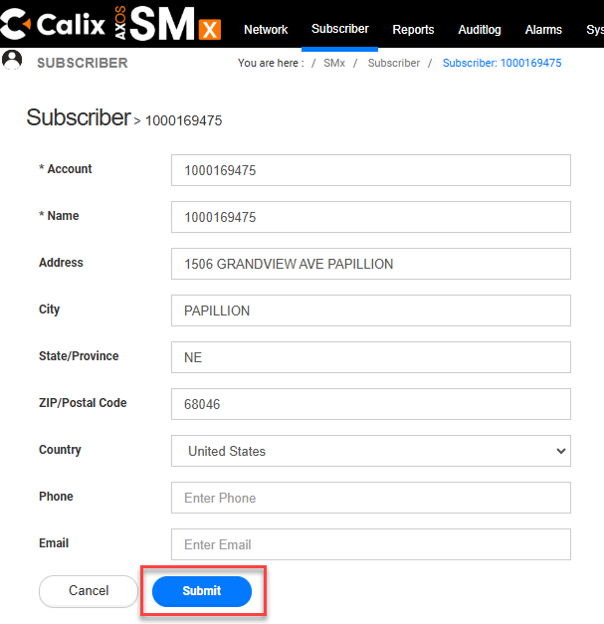
A Subscriber is updated successfully message will appear if the change was successful.

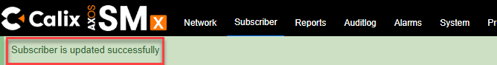

Edit Data Service
This is used to change the VLAN’s. In order to change the Account, Name, or Address, see Edit Subscriber.

Step | Action
View Customer’s TN / DTN (See steps for View Service if needed).
Select Edit Icon .

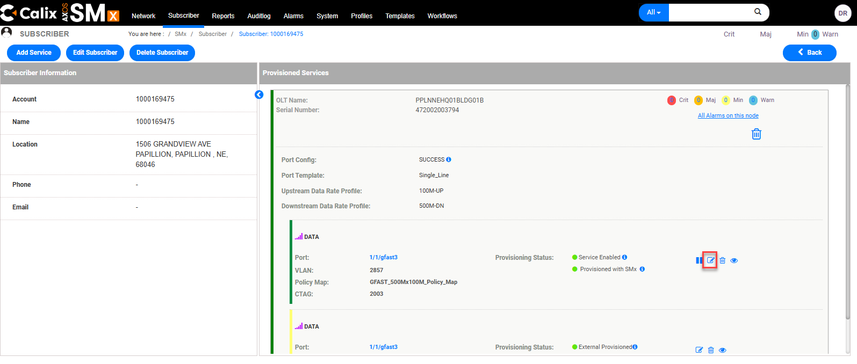
Agent can edit Policy Map (Speed), VLAN (VPI/SVLAN) and/or C-TAG (VCI/CVLAN).

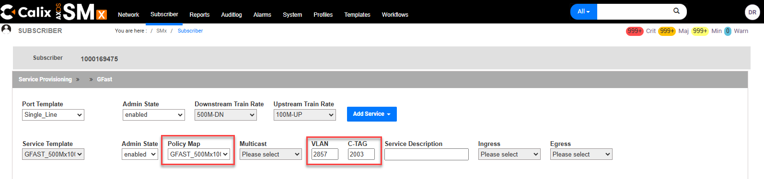
Select Update Service (bottom right).
Tip: Select Cancel if agent would like to return to the previous screen without saving any changes.

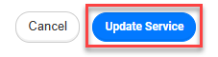

Pause Service

Step | Action
View Customer’s TN / DTN (See steps for View Service if needed). Select Pause Icon
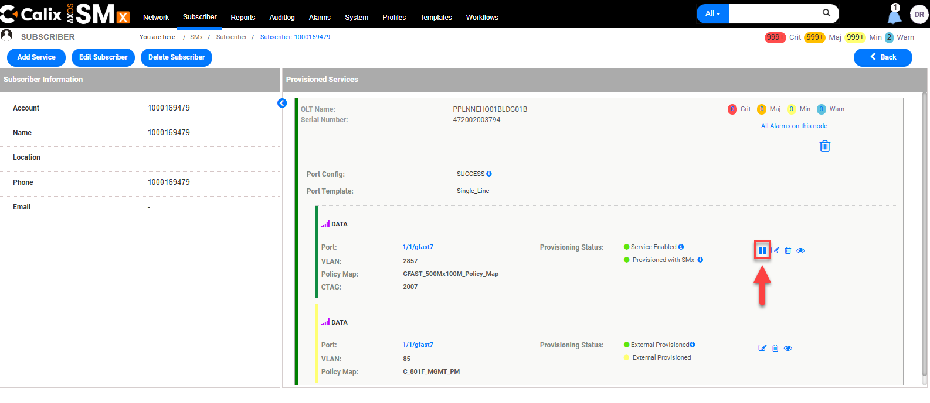
 | Select Confirm on the Alert.
A Services have been paused successfully message will appear.
When service is paused, the pause button changes to a Resume button .
The Provisioning Status shows Service Paused.
The color panel next to the DATA service shows yellow instead of green.

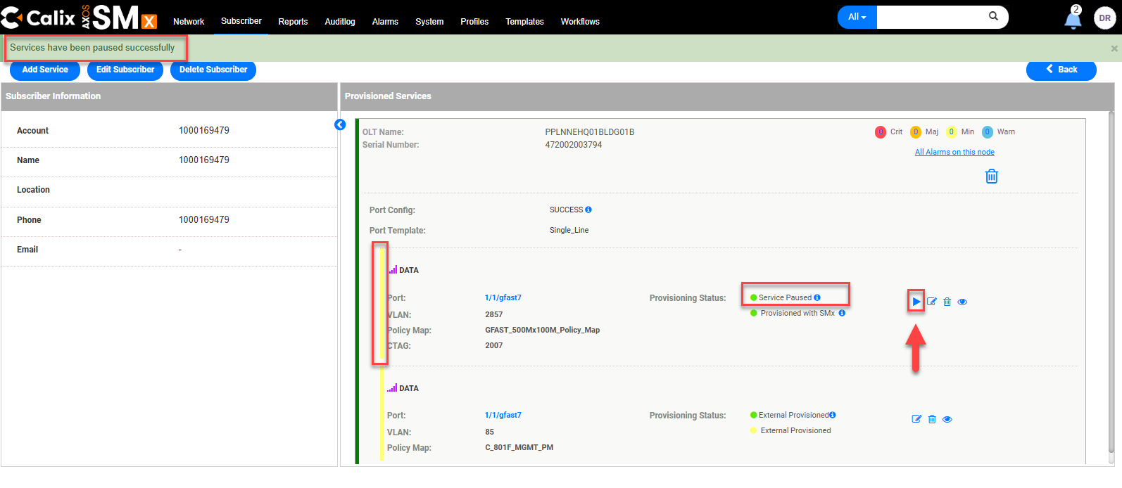

Resume Service
Step | Action
View Customer’s TN / DTN (See steps for View Service if needed). Select the Resume Icon

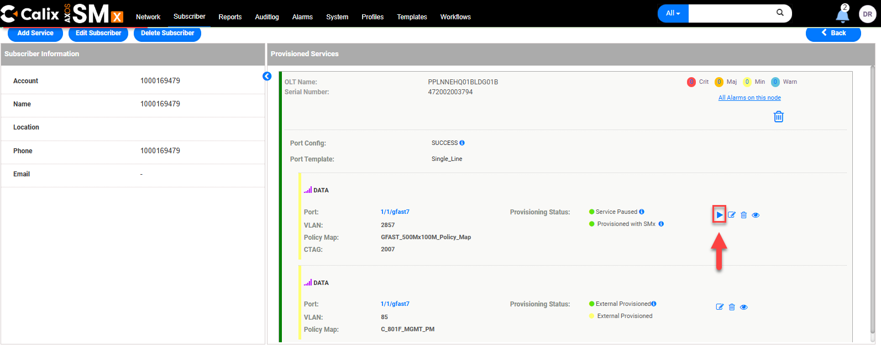
A Services have been resumed successfully message will appear.
The Resume button will change to a Pause button .
The Provisioning Status shows Service Enabled.
The color panel next to the DATA service shows green instead of yellow.

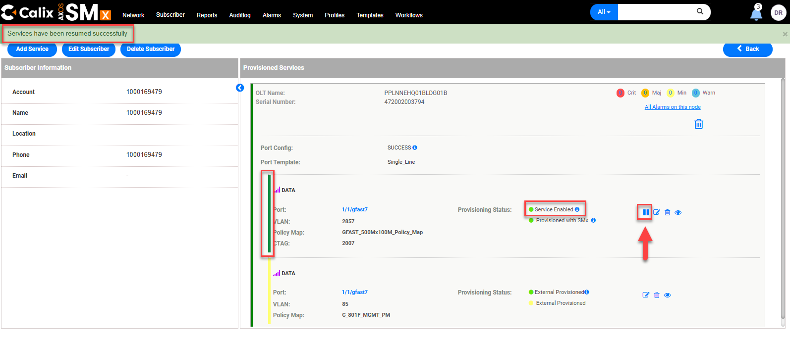

Deleting Service
There are two steps when deleting services.
Deleting the Subscriber and deleting the ONT

Deleting the Subscriber

Step | Action
View Customer’s TN / DTN (See steps for View Service if needed).

Select Delete Subscriber.

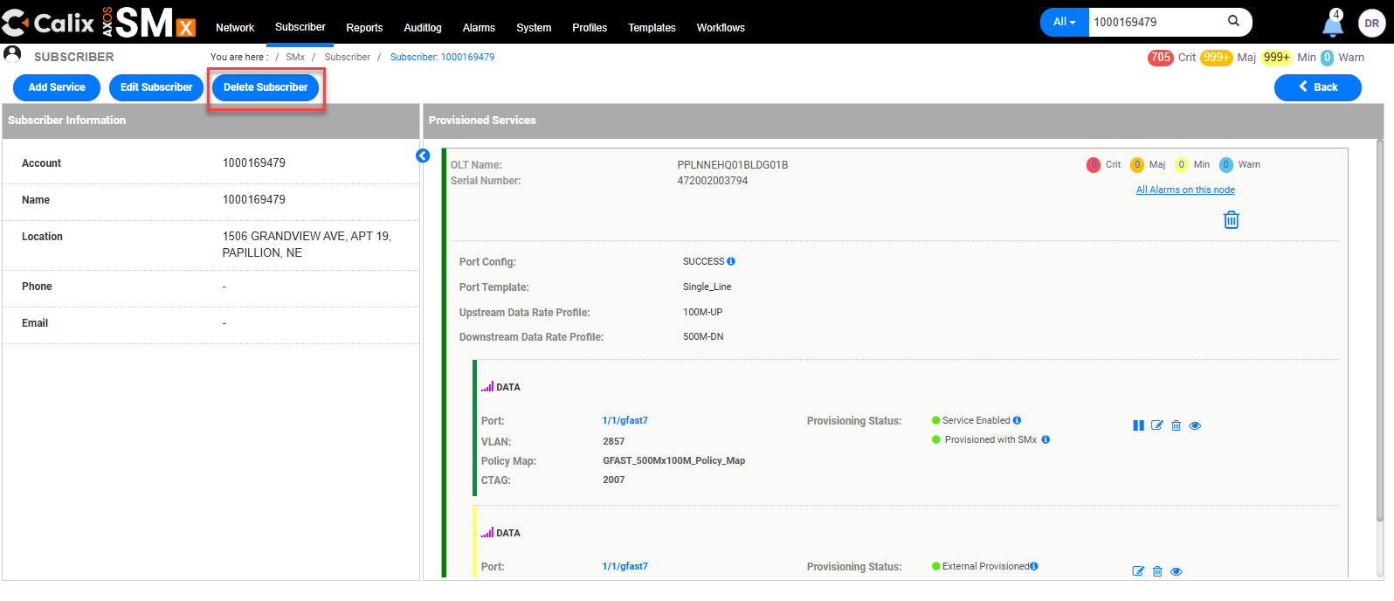
Select Force Delete.
It does NOT delete the ONT. If the ONT needs to be deleted follow the steps in the Deleting the ONT section of this document.
Selecting Delete can only be used if there are no services provisioned.

 | A Deleted subscriber (DTN/TN) successfully message will appear if successful.

Deleting the GFAST Interface
Step | Action
View Subscriber’s TN / DTN (See steps for View Service if needed).

Select the subscriber TN/DTN .

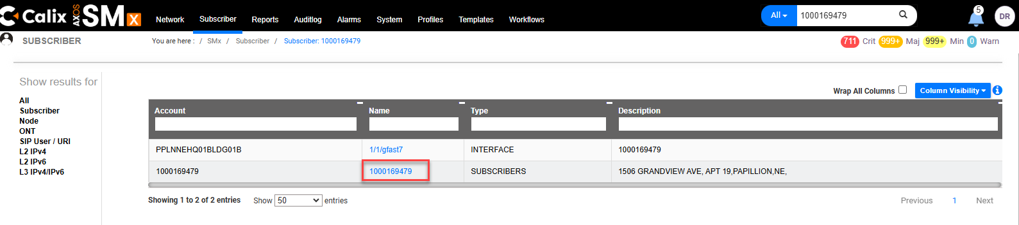
Select Delete single service .

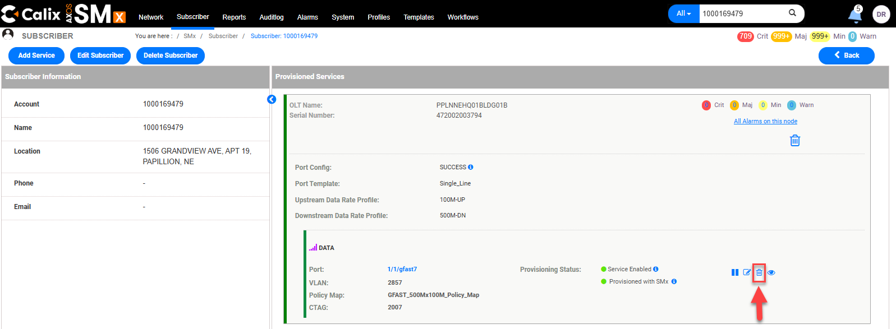
 | Select Force Delete.
 | A Service deleted successfully message will appear if successful.
The Provisioned Services section will appear empty.

Note: Follow the steps to either Create Subscriber or to Delete Subscriber according to the next action required.

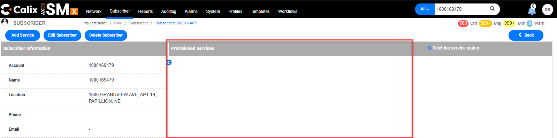

Firmware
SmartNID Firmware cannot be found in G.Fast because the SmartNID is behind a bridge device.
The SmartNID Firmware that is shown would be on the bridge device, and not the SmartNID.

Troubleshooting
Always attempt normal troubleshooting steps -- Verify customer is provisioned correctly (VLANs match assignment & speed is correct) and ensure an IMPROV account exists. If the steps below do not resolve the issue, try Rip/Rebuild or ask the technician to try a replacement Modem if needed.

How to Verify the Subscriber’s IP Address

Step | Action
View Customer’s TN / DTN (See steps for View Service if needed). Select View Icon under Data.
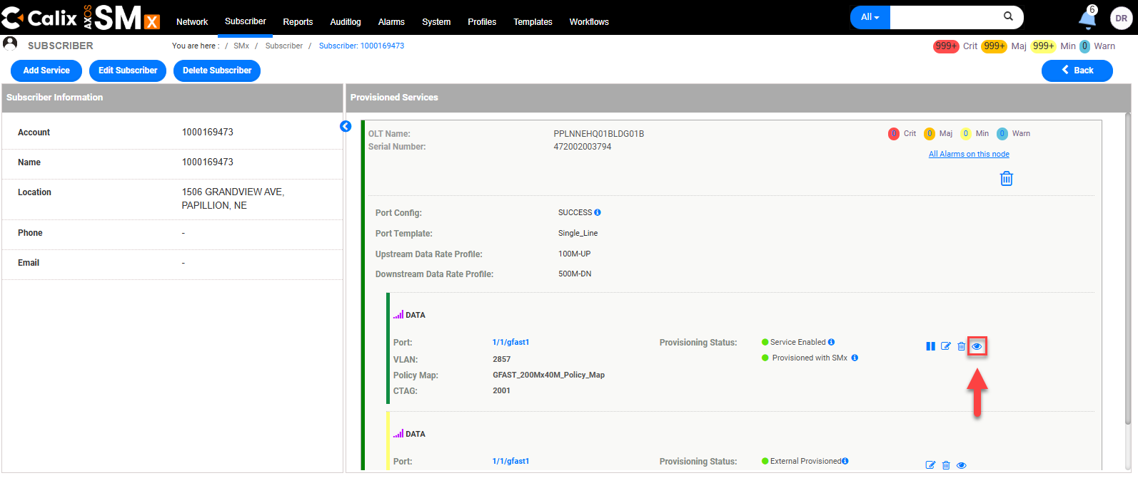
Select IPv4. The IP Address will be listed under the IP Address column.
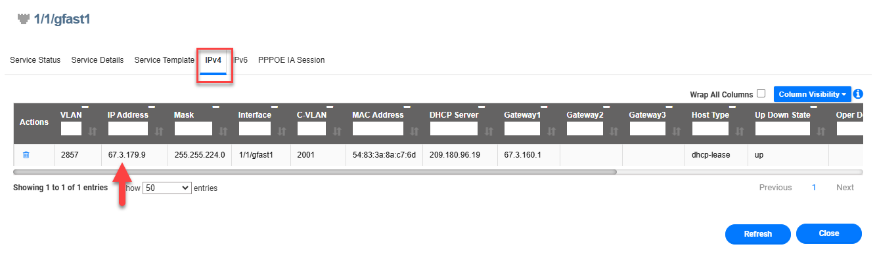

How to View Authentication on all of the Ports on the DPU

Step | Action
View Customer’s Device (See steps for View Service if needed).

Select System.
Select L2 Subscriber IPs.
Select DHCPv4 (or verify it is already selected.)
All active IP addresses in the device will be listed under the IP Address column.

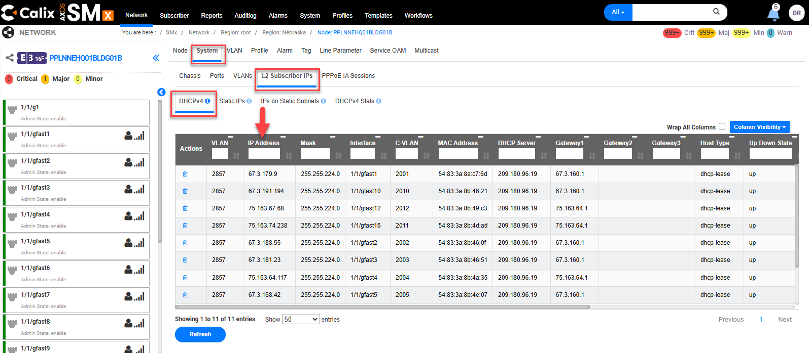

How to Resynchronize the CLLI
If it is identified that it is necessary to resynchronize the CLLI, please follow the steps below.

Note for the Structure Load Team working New Build jobs:
An issue has been identified where sometimes only blank white space is seen when the expected result should look something like this:

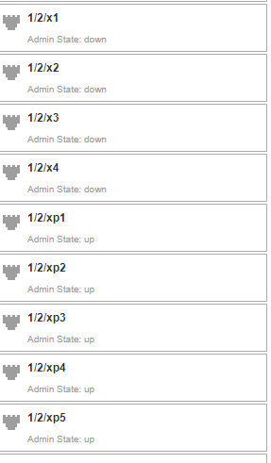

This action will also be needed if project notes in Sitetracker say something like this STRUCTURELOAD: PLEASE RE-SYNC THE CLLI IN SMX, IF YOU NEED ASSISTANCE PLEACE REACH OUT TO IAN BAKER; ALL ISP ACTIVITIES ARE COMPLETE

Step | Action
1 | Enter the OLT in the Search bar.  Select the looking glass icon to search.  
2 | Select the CLLI link.  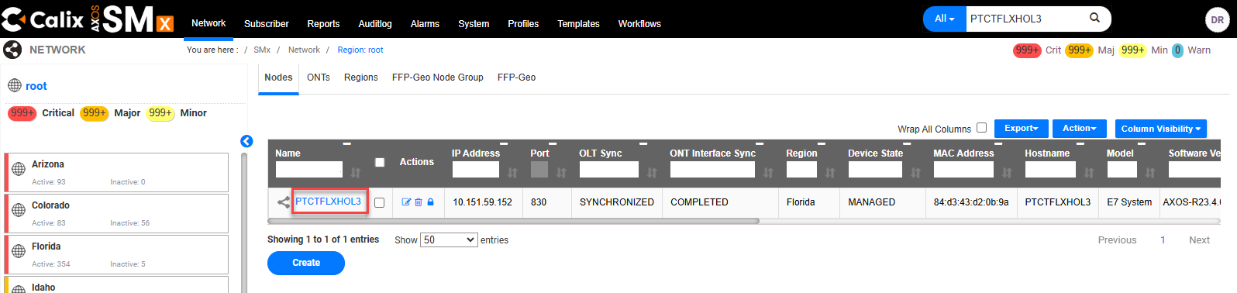
3 | Select the Actions drop down and select it to open the drop-down menu.  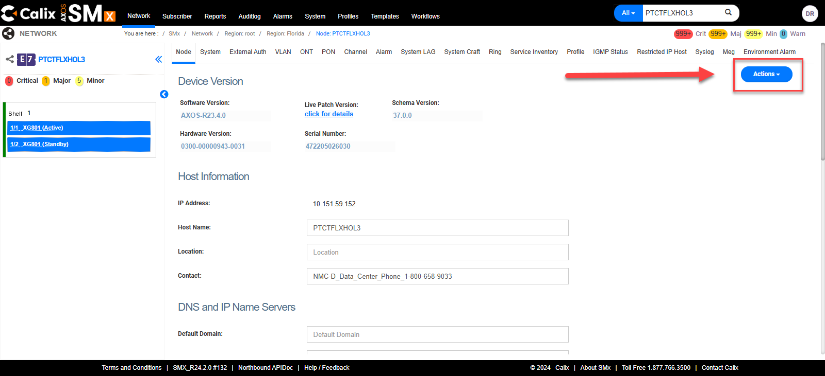
4 | Locate and select Resynchronize  Tip: Agent may need to scroll down to locate Resynchronize.  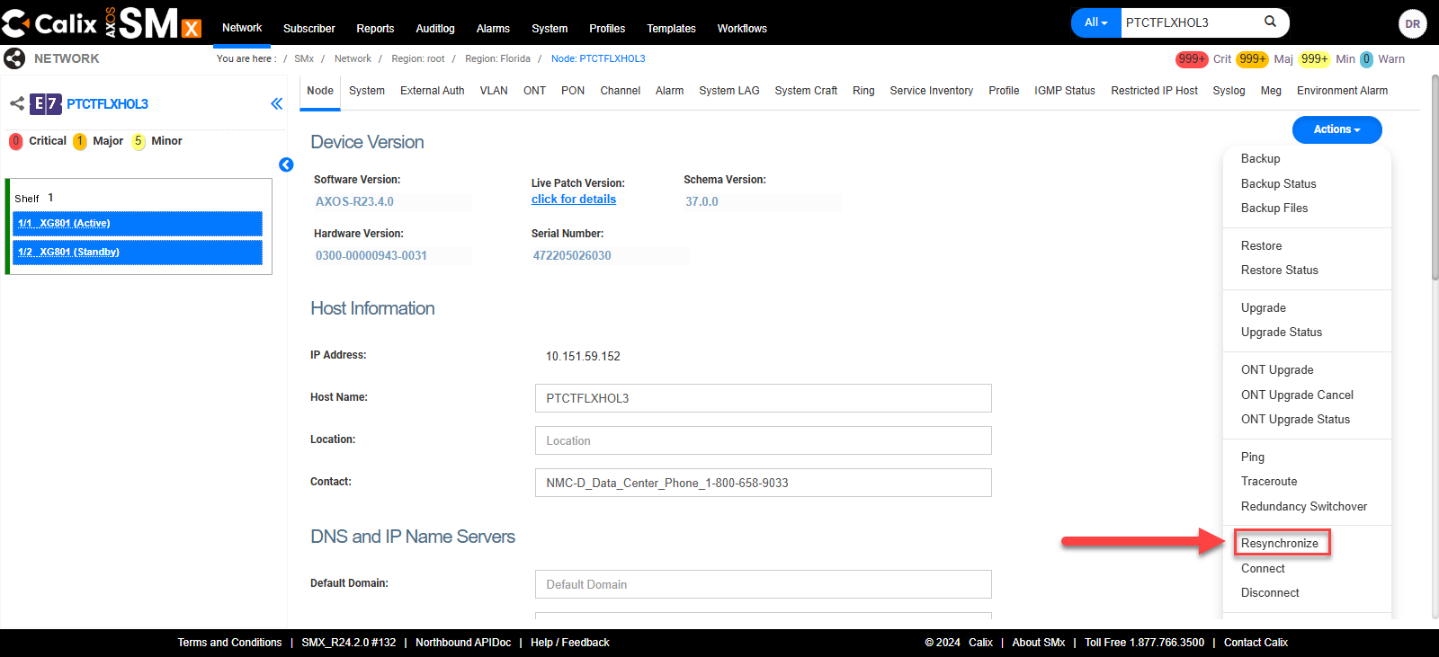
5 | After Resynchronize is selected a very brief pop-up window will display and then disappear.  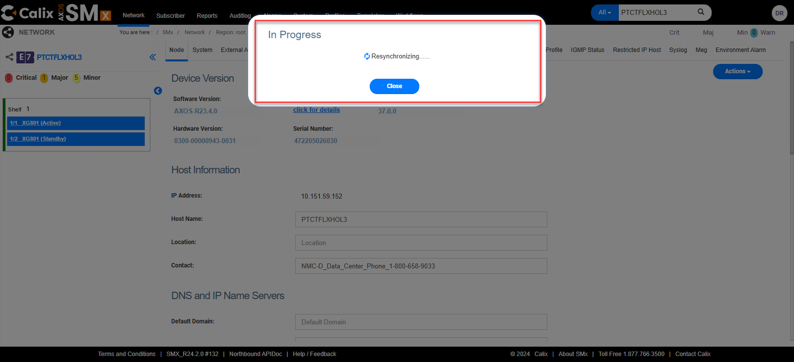
6 | Then a green banner will briefly appear at the top of the screen that displays the message Data sync task started successfully.  Note: There is no confirmation message that Resychronizing has been completed.
7 | Search the OLT again and action accordingly.

Videos
Several videos have been created and the links for these videos can be found in the Related Documents section of this document:

- G.Fast – Calix SMx Create Programming
- G.Fast – Calix SMx Verify Programming

Document Management

Document Management
AUTHORS
Author | SME |  | Name |  |  |  | Telephone Number | E-mail Address
X |  |  | Debra Rudrud |  |  |  | 214-617-2123 | Debra.Rudrud@forgedfiber37.com
 | X |  | Kyle Field |  |  |  |  | Kyle.Field@forgedfiber37.com
 | X |  | Kimberly Evans
REVISIONS
Date |  | Issue |  | Revised By |  | Comments
04/26/22 |  | 1 |  |  |  | Initial Version
06/24/22 |  | 2 |  | Angela Cox |  | Updated for Certification Review
03/01/23 |  | 3 |  | Debra Rudrud |  | Updated document author from Angela Cox to Debra Rudrud  Added section How to Resynchronize the CLLI
12/11/24 |  | 4 |  | Debra Rudrud |  | Added Videos section and the links to the videos in the Related Documents section.  Added Resume Service and Deleting the GFAST Interface sections.  Re-titled DHCP Lease (Customer) to How to Verify the Subscribers IP Address  Re-titled DHCP Lease (All Subscribers) to How to View Authentication on all of the Ports on the DPU.  The SMx Interface has changed. Updated images and language affected by this change.
03/26/25 |  | 5 |  | Debra Rudrud |  | Corrected the XGS link for Lumen.  Updated the language for the Brightspeed SMx link name to identify this is where WI T096 is.
05/09/25 |  | 6 |  | Debra Rudrud |  | The traditional way to View Service is broken with no ETR. Added the steps for the temporary process to View Service.
05/15/25 |  | 7 |  | Debra Rudrud |  | Updated section names for View Service section.
11/10/25 |  | 8 |  | Joela Flaxa |  | Removed COR-TSC from title.
11/17/25 |  | 9 |  | Debra Rudrud |  | Updated the URL Links for NetworkCo Split. Lumen has it’s own SMx and NetworkCo SMx.
02/23/26 |  | 10 |  | Debra Rudrud |  | Added context in the Overview section.  Added document links in the Related Links section.
02/24/26 |  | 11 |  | Debra Rudrud |  | Added the Firmware section.  Updated to FF37 template.
APPROVAL
Name |  |  |  |  | Title |  |  |  | Date Approved
Liz Bordano |  |  |  |  | Manager – Mass Markets Ops Excellence |  |  |  | 06/24/2022

